Treasurer’s Report for Sixteenth year to 31st January 2020

We continue to give thanks to God for His provision for the work again this year when
Gifts and donations have shown a small rise compared to 2018 of 6%.
We thank God for the generous hearts he has given.
We ended the year with less on deposit than at the beginning as we transferred
more to Kenya.
You will see from the Auditor’s statement that the opening balance was £38,303
Income for the year was £98,713 (£82,357) and the closing bank balance was
£25,015. We transferred £108,000 (£80,000) to Kenya in the year.

Financial Highlights
Gifts totalled £87,283 (£82,235) and the Inland Revenue contributed £11,430
(£13,631) with thanks due to the 296 people who have signed Gift Aid forms. Gift aid
collection has shown a 16% decrease partly explained by small variation in period
covered by claims.

Eight new standing orders totalling £250, $200 and CAD 20 per month were set up
during the year. Gift Aid were appropriate is claimed on UK donations. The increase
in regular giving continued to show slow growth. These, plus contributions for
annually sponsored children and including Gift Aid, give a monthly total of just over
£4,000 and represent our core income.

All the funds transferred to Kenya continue to go to the account of Kind Fund Society
of Kenya. The pie chart below gives a summary of how funds were utilised in Kenya

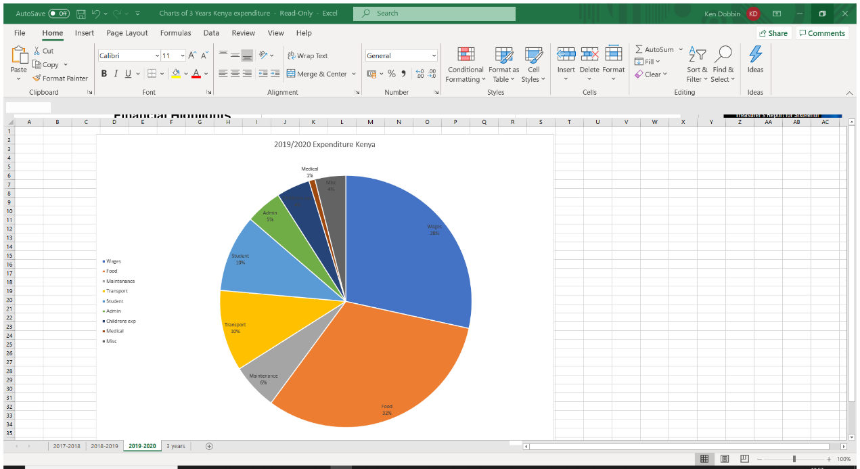

The Kenyan shilling mainly because of Brexit and the weakness of stg has continued to strengthen resulting in the exchange rate for the pound dropping throughout the year bottoming in September 2019 around 123 ksh to £1. We were experiencing a 25% drop in value from peak of 164 in 2016. We give thanks that in the current year the £ has fared much better with rates recovering currently in August 20 to above 140 ksh to £

You will have noticed £4,001 recorded as spent on administration. This is accounted for by several cheques issued locally but each one covered by a specific gift towards administration and therefore additionally securing gift aid. All funds except these were transferred to Kenya for the programme.

All expenses for those travelling to Kenya continue to be met personally by the traveller.

Thanks
I would like to again take this opportunity to again say thank you:

First of all, thank you to all of you who have responded to God’s call on your resources to support the work.

To those who have invited members of the Kindfund Team to speak at meetings and
who have organised other events to raise support we very much appreciate both the
financial support and the opportunity to tell others the good things God is doing.

To the members of the Kindfund Committee who have been faithful in prayer and generous with their time giving us of their wisdom.

To all those who have visited the projects and as a result have been inspired to support and represent it to others. To all our friends and co-workers in Kenya, and finally thanks to our auditor Norman Carson FCCA, CHE, FHFMA whose advice and recommendations have helped us ensure strong financial management and accountability.

I will be happy to answer any questions.

Ken Dobbin
Treasurer

